|  |  |  |
| --- | --- | --- |
|  | CSC ESA  GROUND SEGMENT OPERATIONS FRAMEWORK  OPERATIONS COORDINATION DESK SERVICE  [OMCS] SentiBoard End User Manual |  |

|  |  |  |  |
| --- | --- | --- | --- |
| **Title:** | **CSC Coordination Desk – [OMCS] SentiBoard End User Manual** | | |
| **Abstract**: | This document represents the End User Manual of SentiBoard | | |
| **Author:** | CD Dev Team | **Verified:** | Andrea Bolle |
|  | **CSC Coordination Desk Dev Team** |  | **CSC Coordination Desk Service Manager** |
| **Approved**: | Andrea Bolle | **Authorised:** | Roberto Zaccari |
|  | **CSC Coordination Desk Service Manager** |  | **Product Assurance Manager** |
| **Accepted by ESA:** |  |  |  |
|  | | |  |
| **Filename:** | **CSC Coordination Desk - [OMCS] SentiBoard End User Manual.docx** | | |

**Document Status Sheet**

|  |  |  |  |  |  |
| --- | --- | --- | --- | --- | --- |
| **ISSUE** | **DATE** | **AUTHOR** | **VERIFIED** | **APPROVED** | **REASON OF THE MODIFICATION** |
| 1.0 | 25/07/2024 | CD Dev Team | A. Bolle | A. Bolle | First Issue |

**Document Change Record History**

|  |  |  |  |  |
| --- | --- | --- | --- | --- |
| **No** | **Change In Issue** | **Description of Change** | **Section** | **Change made by** |
|  |  |  |  |  |

**Table of Content**

1 Introduction 6

1.1 Purpose 6

1.2 Structure of the document 6

2 Applicable and Reference Documents, Acronyms 7

2.1 Applicable Documents 7

2.2 Reference Documents 7

2.3 Acronyms and Abbreviations 7

3 SentiBoard Web Application 9

**Index of Figures**

Figure 3‑1 SentiBoard Home page 9

Figure 3‑3 The About page 10

Figure 3‑4 The Acquisition Status page 10

Figure 3‑5 The Events page 11

Figure 3‑6 The Datatakes page 12

Figure 3‑7 The Datatakes details panel, showing the completeness per product type 12

Figure 3‑8 The Publication Statistics page 13

**Index of Tables**

**Table 1 Applicable Documents** 7

**Table 2 Reference Documents** 7

**Table 3 Acronyms and abbreviations** 8

# Introduction

The present document is delivered in the context of the OMCS branch of the CSC Coordination Desk Programme.

## Purpose

The purpose of the present document is to describe the main pages and characteristics of the SentiBoard, formerly called “Public Dashboard”.

## Structure of the document

The present document is structured as follows:

* Chapter 1: Introduction – this Chapter;
* Chapter 2: Applicable and Reference documents, Acronyms
* Chapter 3: SentiBoard Architecture

# Applicable and Reference Documents, Acronyms

## Applicable Documents

The following table lists the applicable documents.

| **Refer.** | **Title** | **Code** |
| --- | --- | --- |
| [AD-IL] | Invitation To Tender for ESA Ground Segment Operations Framework Operations Coordination Desk Service | AO/1-10177/12/I-BG-SC 13.05.2021 |
| [AD-SOW] | Copernicus Space Component - ESA Ground Segment Operations Framework – Coordination Desk Service - STATEMENT OF WORK | ESA-EOPG-EOPGC-SOW-20 Issue 1.0 |
| [AD-DC] | Appendix 2 to ITT – Draft Contract | 13.05.2021 |
| [AD-STC] | Appendix 3 to ITT – Special Conditions of Tender | 13.05.2021 |
| [AD-ADG] | Auxiliary Data Gathering Technical Requirements | ESA-EOPG-EOPGC-RS-17 Issue 1.0 |
| [AD-WEB] | Web Pages Operations Technical Requirement | ESA-EOPG-EOPGC-RS-14 Issue 1.0 |
| [AD-OMCS] | Operations Monitoring and Coordination Service Technical Requirements | ESA-EOPGEOPGC-RS-18 Issue 1.0 |
| [AD-SLA] | SLA and Key Performance Indicators | EOPG-EOPGC-TN-43 Issue 1.0 |
| [AD-SEC] | Coordination Desk Service - Security Requirements Document | ESA-EOPG-EOPGCS-SP-13 Issue 1.0 |
| [AD-CDP] | CSC PDGS/CDS Coordination Desk Procedures | COPE-GSEG-EOPG-PR-14-0035 Issue 2.0 |
| [AD-MNT] | CSC Ground Segment Coordinated Maintenance Procedure, | COPE-PMAN-EOPG-PR-14-0001 Issue 4.0 |
| [AD-CM] | CSC Ground Segment Configuration Management Requirements, | ESA-EOPG-CSCOP-RS-14 Issue 1.0 |
| [AD-AMP] | CSC Ground Segment Anomaly Management Procedure, | GMES-GSEG-EOPG-PR-13-0008 Issue 4.0 |
| [AD-CIDL] | CSC Coordination Desk – Configuration Data Item List | ESA-EOPG-EOPGC-TN-45 Issue 1.0 |

**Table 1 Applicable Documents**

## Reference Documents

The following table lists the reference documents.

| **Refer.** | **Title** | **Code** |
| --- | --- | --- |
| [RD-ARCH] | CSC Operations – ESA Framework – Ground Segment Architecture, | ESA-EOPG-EOPGC-TN-7 Issue 1.2 |
| [RD-MICD] | Copernicus Space Component ESA Ground Segment Operations Framework-MasterICD | ESA-EOPG-EOPGC-IF-6 Issue 1.2 |
| [RD-CSDAR] | Copernicus Sentinel Data Access Report https://scihub.copernicus.eu/twiki/pub/SciHubWebPortal/AnnualReport2019/COPESERCO-  RP-20-0570_-_Sentinel_Data_Access_Annual_Report_Y2019_v1.0.pdf |  |
| [RD-EUG] | EU green public procurement criteria for data centres, server rooms and cloud services | SWD(2020) 55 final |
| [RD-NRJ] | Acton, M., Bertoldi, P., Booth, J., Flucker, S., Newcombe, L., Royer, A. and Tozer, R., 2019 Best Practice Guidelines for the EU Code of Conduct on Data Centre Energy Efficiency, European Commission, Ispra, 2018, | JRC114148 |
| [RD-GL] | CSC Sentinel Ground Segment Operations Glossary | ESA-EOPG-EOPGC-TN-13 |
| [RD-STB] | System Technical Budget | ESA-EOPG-EOPGC-TN-09 Issue 1.4 |

**Table 2 Reference Documents**

## Acronyms and Abbreviations

The following table contains all acronyms and abbreviations used in the current document.

| Acronym/Abbreviation | Definition |
| --- | --- |
| API | Application Programming Interface |
| AUX | Auxiliary |
| AUXIP | Auxiliary Interface (delivery) Point |
| CADU | Channel Access Data Unit |
| Cal/Val | Calibration/Validation |
| CCD | Copernicus Coordination Desk |
| CFI | Customer Furnished Item |
| COM | European Commission |
| CSC | Copernicus Space Component |
| CVIP | Calibration & Validation Interface (delivery) Point |
| DD | Data Distribution |
| DP | Documentation Package |
| DPA | Dynamic Procurement Approach |
| E2E | End-to-End |
| EC | European Commission |
| ECMWF | European Centre for Medium-Range Weather Forecasts |
| EDRS | European Data Relay Satellite System |
| EO | Earth Observation |
| EOF | ESA Operations Framework |
| EOP | Earth Observation Programme |
| ESA | European Space Agency |
| EU | European Union |
| EUM | EUMETSAT |
| FC | Frame Contract |
| FTP | File Transfer Protocol |
| GS | Ground Segment |
| HKTM | Housekeeping Telemetry |
| ICD | Interface Control Document |
| IF | Interface |
| IP | Interface (delivery) Point |
| IPF | Instrument Processing Facility |
| ITT | Invitation To Tender |
| KPI | Key Performance Indicators |
| LTA | Long Term Archive |
| MP | Mission Planning |
| MPIP | Mission Planning Interface (delivery) Point |
| ODP | On-Demand Processing |
| ODPRIP | On-Demand Processing Interface (delivery) Point |

**Table 3 Acronyms and abbreviations**

# SentiBoard Web Application

[SentiBoard](https://operations.dashboard.copernicus.eu/index) (formerly called “Public Dashboard) is a web application promoted by the European Space Agency in the framework of the Coordination Desk Programme.

This web application is meant to provide users with real-time, aggregated data about the status of the acquisition of the areas of their interest, the presence of issues potentially having an impact on data production, the planning of the future acquisitions and the details on the status of every data product.

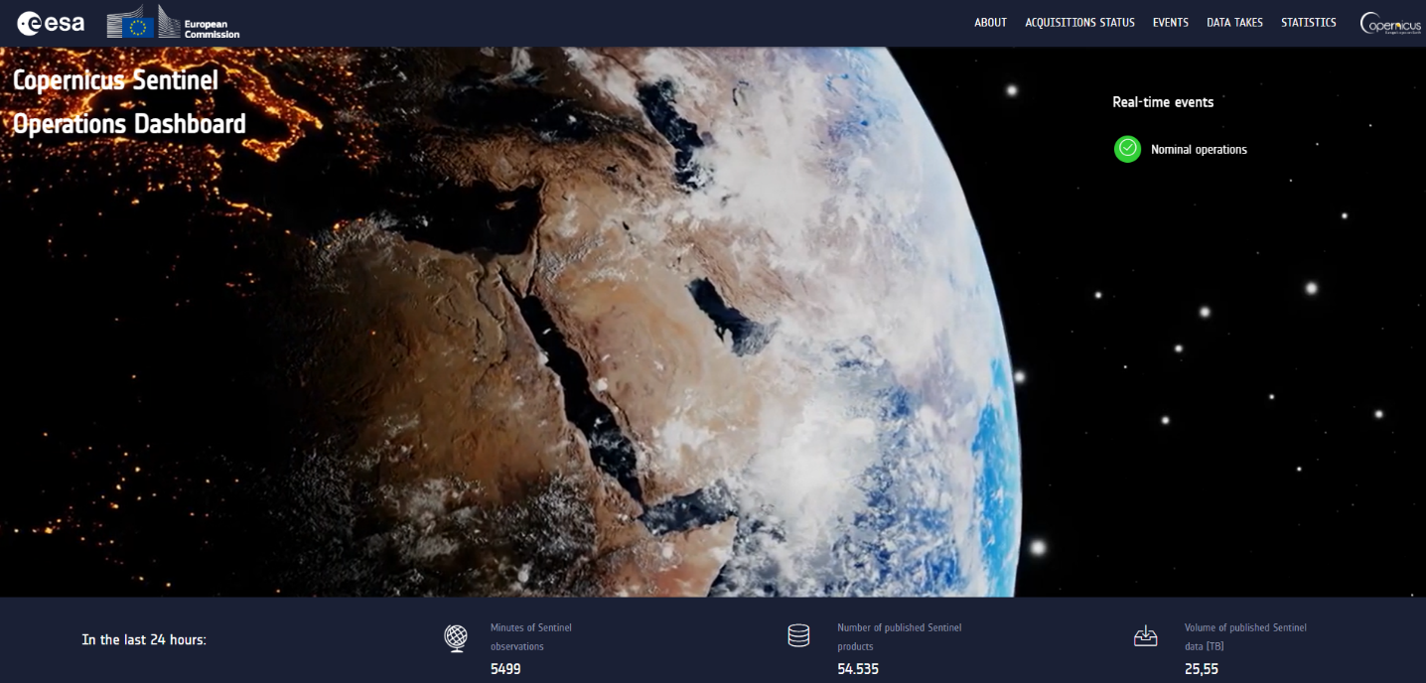

Figure 3‑1 SentiBoard Home page

More in details, SentiBoard offers the following views:

* An [About](https://operations.dashboard.copernicus.eu/about.html) page, with the general information on the web application
* An [Acquisition Status](https://operations.dashboard.copernicus.eu/acquisitions-status.html) page, with an interactive, 3D globe permitting to see in both real and simulated time the position of the Sentinel satellites and the past, current and future acquisitions
* The [Events](https://operations.dashboard.copernicus.eu/events.html) page, showing the issues with a tangible effect on data takes (acquisitions), together with a synthetic view of the impact on production. In case of major events, the details of the issue report also the link to the relevant news on Sentinel Online
* The [Data Takes](https://operations.dashboard.copernicus.eu/data-takes.html) page, collecting the status of the data take acquisition up to 3 months in the past. It reports also the future acquisitions foreseen in the next two days
* The [Publication Statistics](https://operations.dashboard.copernicus.eu/publication-statistics.html) page, providing a summary of the number / size of Sentinels products, grouped by timeliness type and product types, published in the last 24h, 7 days, 30 days or 3 months

Below, an overview of the web application pages is provided.

The [About](https://operations.dashboard.copernicus.eu/about.html) page reports a summary of all the available pages, together with the contact point in case of issues.

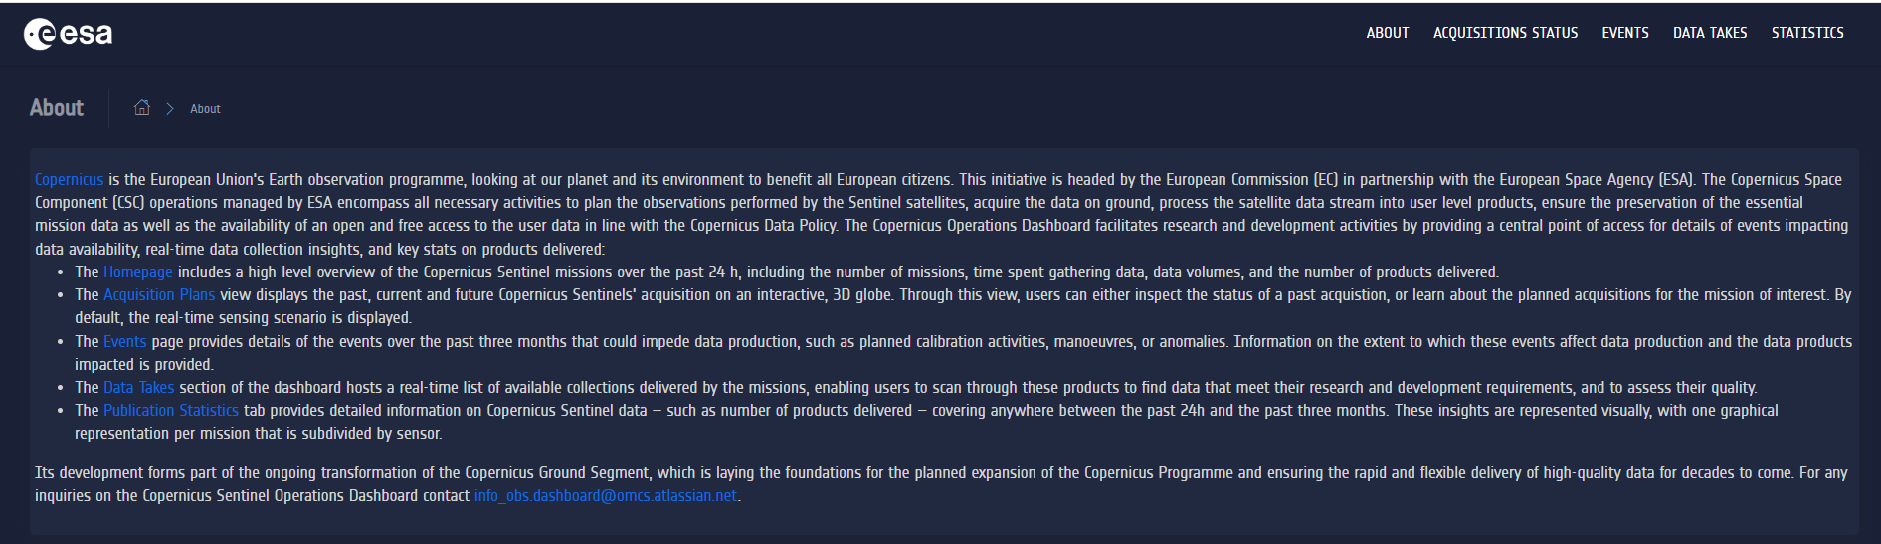

Figure 3‑2 The About page

The [Acquisition Status](https://operations.dashboard.copernicus.eu/acquisitions-status.html) page (formerly “Acquisition Plans”) offers an interactive, 3D globe permitting to see in both real and simulated time the position of the Sentinel satellites and the past, current and future acquisitions. By default, the view shows the real-time position of the Copernicus Sentinels satellite; however, by selecting a datatake from the top-right dropdown menu, the simulation time is shifted to the beginning of the selected acquisition. Datatakes can be filtered by selecting the satellite and the acquisition date. By clicking on the icon, it is possible to inspect the published products relevant to the selected datatake.

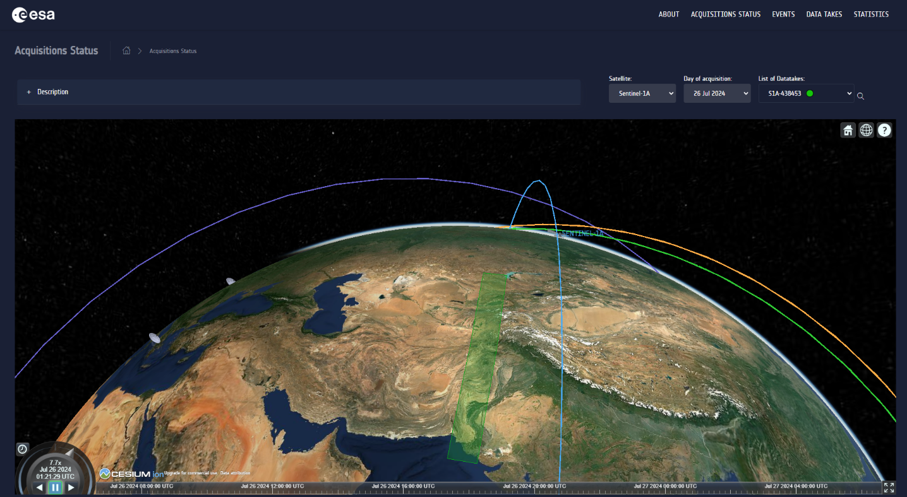

Figure 3‑3 The Acquisition Status page

The [Events](https://operations.dashboard.copernicus.eu/events.html) page is meant to show the issues with a tangible effect on data takes (acquisitions), together with a synthetic view of the impact on production. Events are categorized according to the following issue types:

* Satellite: issue due to instrument unavailability
* Calibration: issue occurred during sensor calibration
* Manoeuvre: issue occurred during the execution of a manoeuvre
* Acquisition: issue occurring during the reception of the data at the ground station
* Production: issue occurred during data processing

By clicking on each occurrence, the list of possibly impacted datatakes considering their sensing times is displayed in the right-side panel, together with further event details. The impact on datatake completeness is represented by the right-side coloured circle. The "green" colour indicates that the total completeness is spared; "orange" is used in case of medium impact; the "red" colour is used when the datatake is lost.

Events can be filtered by entering the satellite name (i.e. "Sentinel-1A"), or the category of interest, in the top-right search box.

In case of major events, the details of the issue report also the link to the relevant news on Sentinel Online.

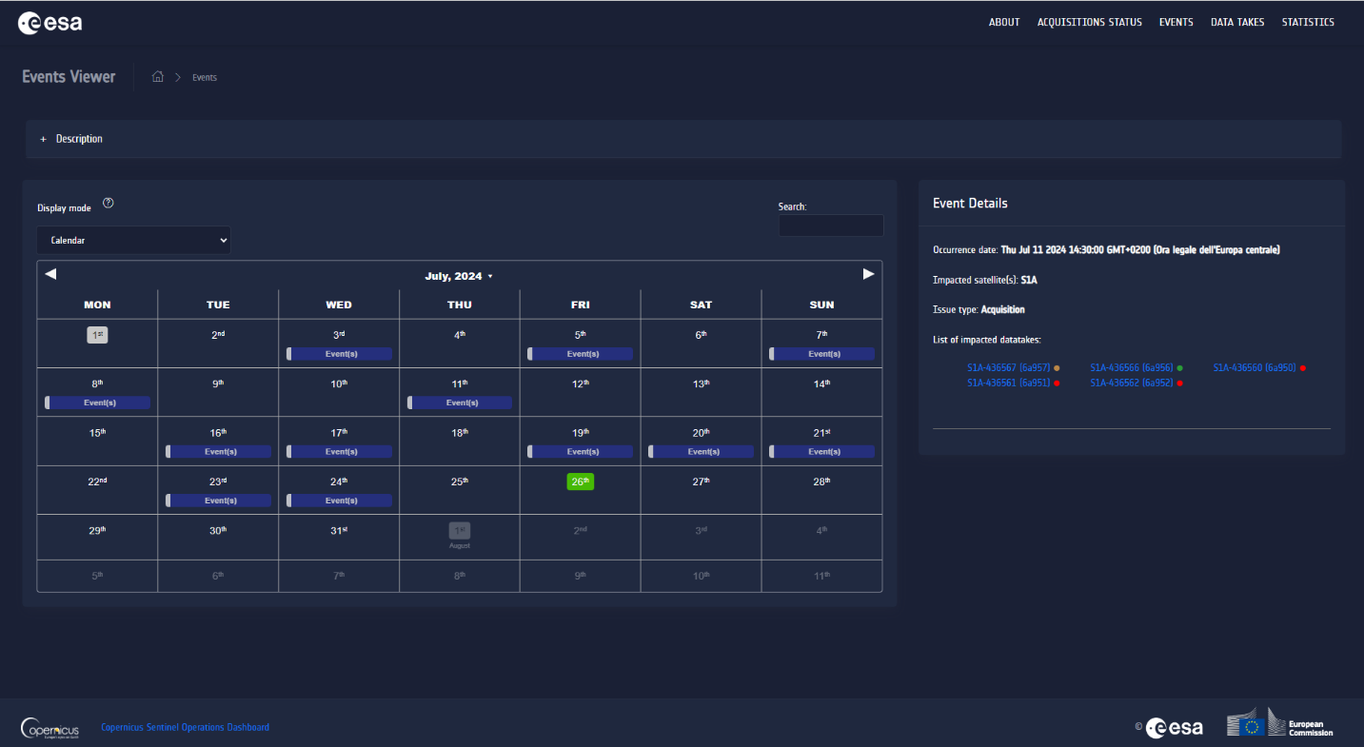

Figure 3‑4 The Events page

The [Data Takes](https://operations.dashboard.copernicus.eu/data-takes.html) page, collecting the status of the data take acquisition up to 3 months in the past. It reports also the future acquisitions foreseen in the next two days. Besides the acquisition platform and sensor mode, this table shows, for every datatake, the acquisition status and the total publication completeness, expressed in terms of percentage, with a hourly refresh rate. Records can be filtered using the search bar in the top-right side of the table, by entering the mission or satellite name (i.e. "S1" or "S2A"). Datakes can be also filtered on the basis of the sensing time, by selecting the time period of interest in the top-right part of the header bar. Datatakes can be also filtered using combined queries on different columns: as an example, try writing "S1 2024-01-22" to select all datatakes of the Copernicus Sentinel-1 mission, acquired in the specified date.

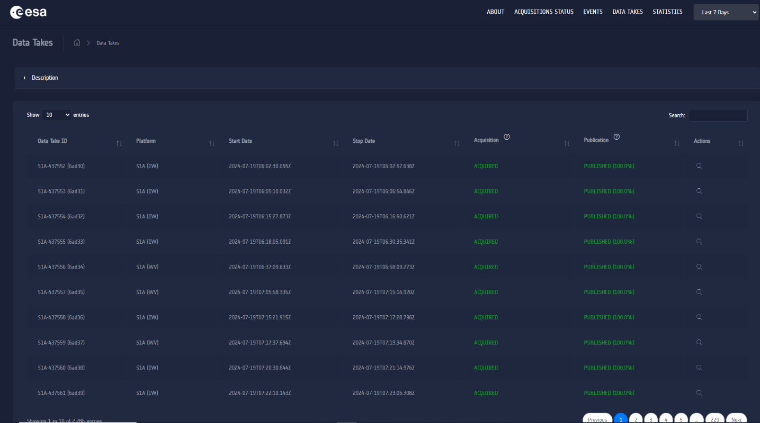

Figure 3‑5 The Datatakes page

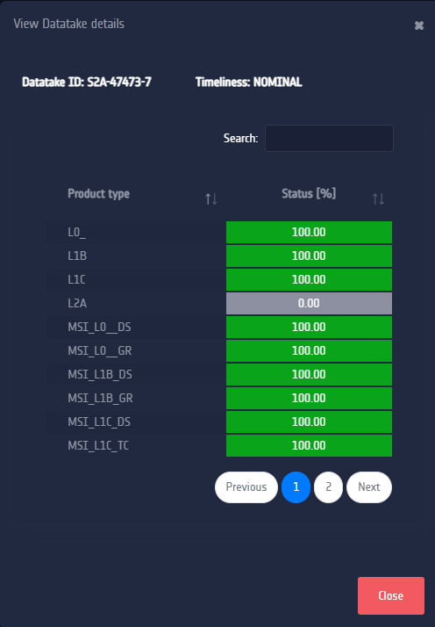

Figure 3‑6 The Datatakes details panel, showing the completeness per product type

The [Publication Statistics](https://operations.dashboard.copernicus.eu/publication-statistics.html) page offers a summary of the total number and volume of products published in the Data Hubs for each Copernicus Sentinel mission, within the selected time interval: last 24 hours, last 7 days, last 30 days and last 3 months (i.e. 90 days) with respect to the current date / time. The view provides also the details about the published products per product level or sensor type (i.e., for Copernicus Sentinel-3). Charts are interactive: by clicking on a label in the legend it is possible to modify the displayed results.providing a summary of the number / size of Sentinels products, grouped by timeliness type and product types, published in the last 24h, 7 days, 30 days or 3 months.

Figure 3‑7 The Publication Statistics page